|  |  |
| --- | --- |
| EX NO: | **CURRENCY CONVERTER** |
| DATE: |
|  |  |

**AIM:**

To develop a JAVA console applications to implement currency converter, distance converter and time converter using package.

**REQUIREMENT:**

JAVA application to implement currency converter (dollar to INR, euro to INR =, yen to INR & vice versa), distance converter (meter to KM, miles to KM and vice versa), time converter (hours to minutes, minutes to seconds, hours to seconds and vice versa) using packages.

Create a package converter library.

Create s class currency converter and define method for dollar to INR, euro to INR, yen to INR & vice versa.

Create a class time converter and define method for meter to km, mile to km and vice versa.

Create a class time converter and define method hours to minutes, hours to seconds & vice versa.

Create package converter app.

**ALGORITHM:**

STEP1: Declare the package as converter library and converter app.

STEP2: Declare a class member as Currency converter, Distance converter and Time converter.

STEP3: Declare all the data member & member function.

STEP4: Create a package as converter app & input the conversion calculation from the converter library package.

STEP5: Get the input from user.

STEP6: Calculate the corresponding conversion.

STEP7: Display the result.

**CLASS DIAGRAM:**

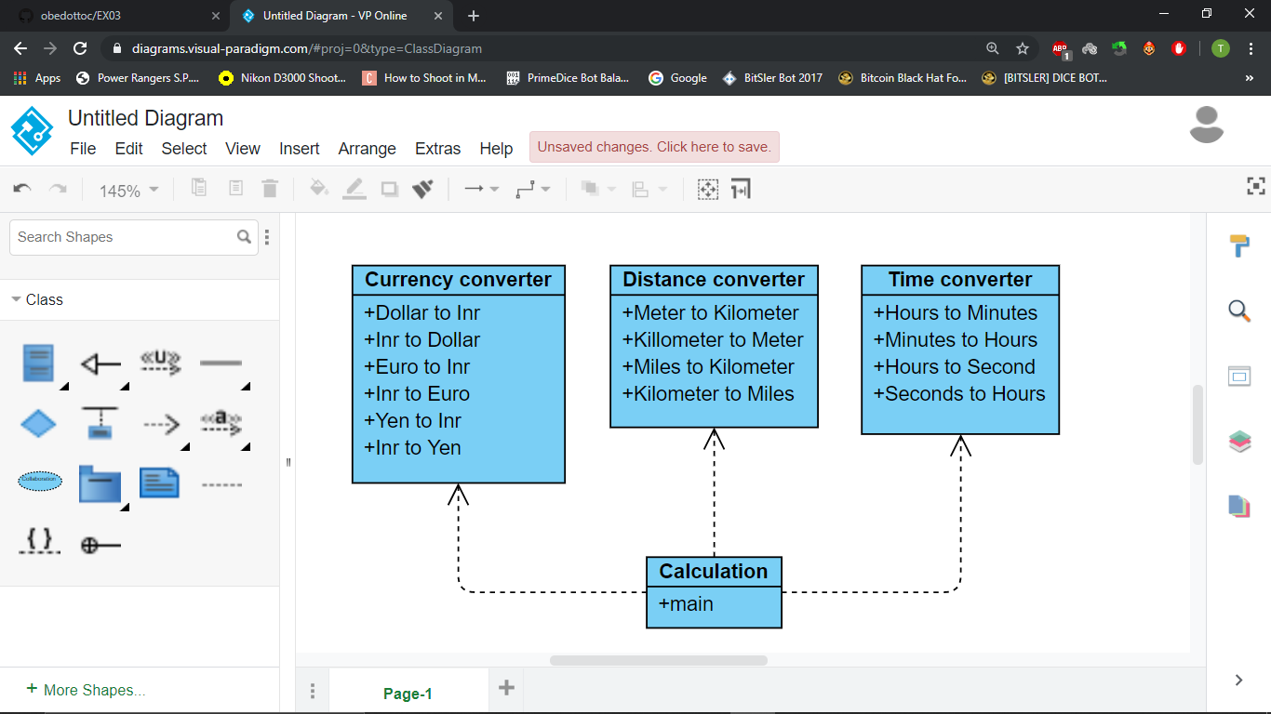

**PROGRAM:**

//*created by Akhshy Ganesh B

// currency converter , time converter, distance converter

// G.Mail : akhshyganeshb@gmail.com

package converterapp;

import java.util.Scanner;

import converterlibrary.CurrencyConverter;

import converterlibrary.DistanceConverter;

import converterlibrary.TimeConverter;

public class calculation1 {

public static void main(String[] args) {

double value1,value2;

int option;

Scanner sc=new Scanner(System.in);

while(true)

{

System.out.println("1.Dollar to Inr: ");

System.out.println("2.Inr to Dollar: ");

System.out.println("3.Euro to Inr: ");

System.out.println("4.Inr to euro: ");

System.out.println("5.Yen to Inr: ");

System.out.println("6.Inr to Yen: ");

System.out.println("7.Meter to Km: ");

System.out.println("8.Km to Meter: ");

System.out.println("9.Miles to Km: ");

System.out.println("10.Km to miles: ");

System.out.println("11.Hours to Minutes: ");

System.out.println("12.Minutes to Hours: ");

System.out.println("13.Hours to Seconds: ");

System.out.println("14.Seconds to Hours: ");

System.out.println("15.EXIT!!!!!!!!!");

System.out.print("Enter your choice:");

option=sc.nextInt();

switch(option)

{Case 1:

System.out.print("Enter Dollar: ");

value1=sc.nextDouble();

value2=CurrencyConverter.dollartoInr(value1);

System.out.printf("%.2fDollar =%.2fRupees \n" , value1,value2);

break;

Case 2:

System.out.printf("Enter Inr: ");

value1=sc.nextDouble();

value2=CurrencyConverter.Inrtodollar(value1);

System.out.printf("%.2fRupee= %.2fDollar \n" , value1,value2);

break;

Case 3:

System.out.printf("Enter Euro: ");

value1=sc.nextDouble();

value2=CurrencyConverter.eurotoInr(value1);

System.out.printf("%.2feuro= %.2fRupee \n" , value1,value2);

break;

Case 4:

System.out.printf("Enter Inr: ");

value1=sc.nextDouble();

value2=CurrencyConverter.Inrtoeuro(value1);

System.out.printf("%.2fRupee= %.2feuro \n" , value1,value2);

break;

Case 5:

System.out.printf("Enter yen: ");

value1=sc.nextDouble();

value2=CurrencyConverter.yentoInr(value1);

System.out.printf("%.2fyen= %.2frupee \n" , value1,value2);

break;

Case 6:

System.out.printf("Enter Inr: ");

value1=sc.nextDouble();

value2=CurrencyConverter.Inrtoyen(value1);

System.out.printf("%.2fRupee= %.2fyen \n" , value1,value2);

break;

Case 7:

System.out.printf("Enter Meter: ");

value1=sc.nextDouble();

value2=DistanceConverter.metertokm(value1);

System.out.printf("%.2fMeter= %.2fKm \n" , value1,value2);

break;

Case 8:

System.out.printf("Enter Km: ");

value1=sc.nextDouble();

value2=DistanceConverter.kmtometer(value1);

System.out.printf("%.2fKm=%.2fMeter \n" , value1,value2);

break;

Case 9:

System.out.printf("Enter miles: ");

value1=sc.nextDouble();

value2=DistanceConverter.milestokm(value1);

System.out.printf("%.2fmiles= %.2fKm \n" , value1,value2);

break;

Case 10:

System.out.printf("Enter Km: ");

value1=sc.nextDouble();

value2=DistanceConverter.kmtomiles(value1);

System.out.printf("%.2fKm= %.2fmiles \n" , value1,value2);

break;

Case 11:

System.out.printf("Enter Hours: ");

value1=sc.nextDouble();

value2=TimeConverter.hourstominutes(value1);

System.out.printf("%.2fHours= %.2fminutes \n" , value1,value2);

break;

Case 12:

System.out.printf("Enter Minute: ");

value1=sc.nextDouble();

value2=TimeConverter.minutestohours(value1);

System.out.printf("%.2feuro= %.2fRupee \n" , value1,value2);

break;

Case 13:

System.out.printf("Enter Hours: ");

value1=sc.nextDouble();

value2=TimeConverter.hourstoseconds(value1);

System.out.printf("%.2fhours= %.2fsecond \n" , value1,value2);

break;

Case 14:

System.out.printf("Enter Seconds: ");

value1=sc.nextDouble();

value2=TimeConverter.secondstohours(value1);

System.out.printf("%.2fSeconds= %.2fHours \n" , value1,value2);

break;

Case 15:

break;

default:

System.out.println("please Enter a valid number: ");

}

if (option==15)

break; }

}

}

**package** converterlibrary;

**import** java.util.Scanner;

**public** **class** CurrencyConverter {

**public** **static** **double** dollartoInr(**double** dollar)

{**double** Inr;

Inr=68*dollar;

**return** Inr;

}

**public** **static** **double** Inrtodollar(**double** Inr)

{**double** dollar;

dollar=Inr/68;

**return** dollar;

}

**public** **static** **double** eurotoInr(**double** euro)

{**double** Inr;

Inr=euro/77;

**return** Inr;

}

**public** **static** **double** Inrtoeuro(**double** Inr)

{**double** euro;

euro=Inr*77;

**return** euro;

}

**public** **static** **double** yentoInr(**double** yen)

{**double** Inr;

Inr=0.64*yen;

**return** Inr;

}

**public** **static** **double** Inrtoyen(**double** Inr)

{**double** yen;

yen=Inr/0.64;

**return** yen;

}

}

**package** converterlibrary;

**public** **class** DistanceConverter {

**public** **static** **double** metertokm(**double** meter)

{**double** km;

km=meter*1000;

**return** km;

}

**public** **static** **double** kmtometer(**double** km)

{**double** meter;

meter=km/1000;

**return** meter;

}

**public** **static** **double** milestokm(**double** miles)

{**double** km;

km=miles*1.609;

**return** km;

}

**public** **static** **double** kmtomiles(**double** km)

{**double** miles;

miles=km/1.609;

**return** miles;

}

}

**package** converterlibrary;

**public** **class** TimeConverter {

**public** **static** **double** hourstominutes(**double** hours)

{**double** minutes;

minutes=hours/60;

**return** minutes;

}

**public** **static** **double** minutestohours(**double** minutes)

{**double** hours;

hours=minutes*60;

**return** hours;

}

**public** **static** **double** hourstoseconds(**double** hours)

{**double** seconds;

seconds=hours/3600;

**return** seconds;

}

**public** **static** **double** secondstohours(**double** seconds)

{**double** hours;

hours=seconds*3600;

**return** hours;

}

}

**OUTPUT :**

1.Dollar to Inr:

2.Inr to Dollar:

3.Euro to Inr:

4.Inr to euro:

5.Yen to Inr:

6.Inr to Yen:

7.Meter to Km:

8.Km to Meter:

9.Miles to Km:

10.Km to miles:

11.Hours to Minutes:

12.Minutes to Hours:

13.Hours to Seconds:

14.Seconds to Hours:

15.EXIT!!!!!!!!!

Enter your choice:1

Enter Dollar: 15

15.00Dollar =1020.00Rupees

**RESULTS:** Thus the java console application for Currency converter, Distance converter & Time converter is verified with output.